**Documentation of Code Integration from Git Commit to Jenkins Build Execution**

1. Initializing a Git Repository

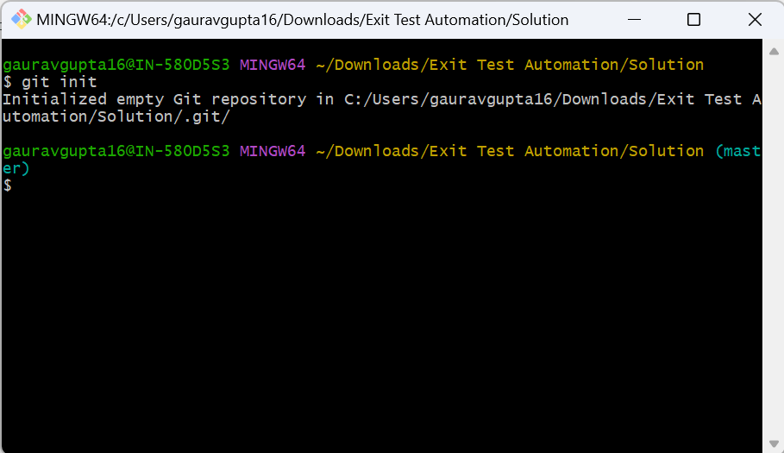

1. Committing Code to Git

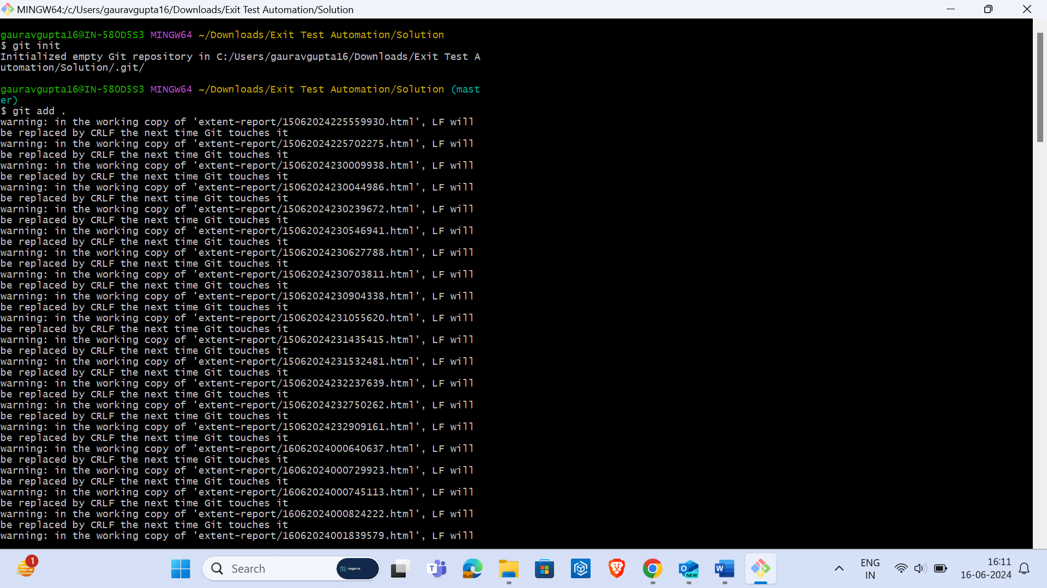

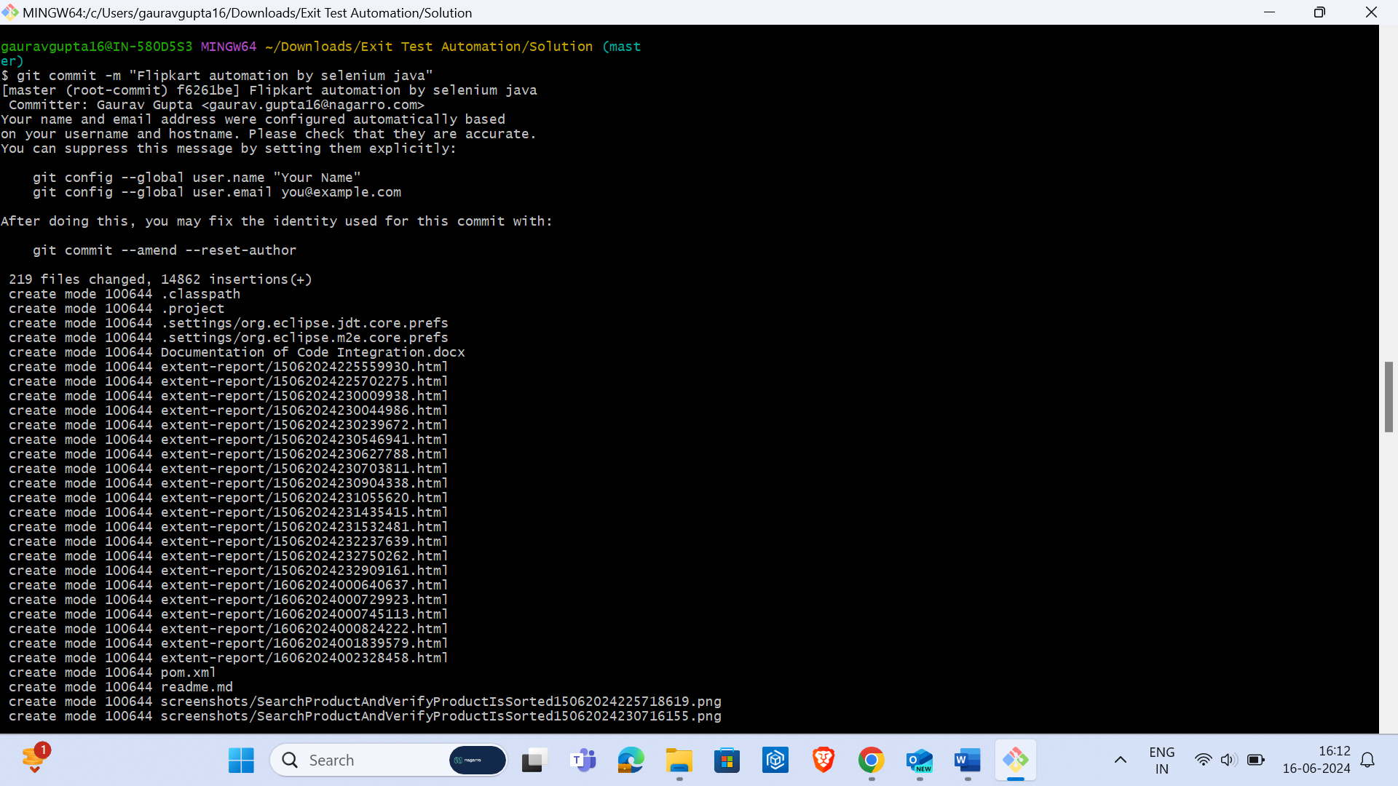

1. Pushing Code to Remote Repository

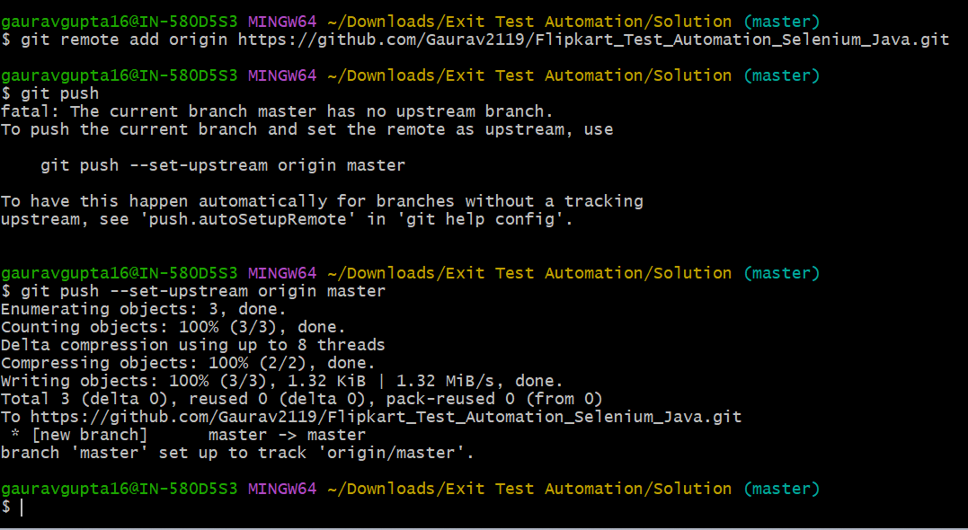

1. Setting Up Jenkins Job
   1. Creating a new item:

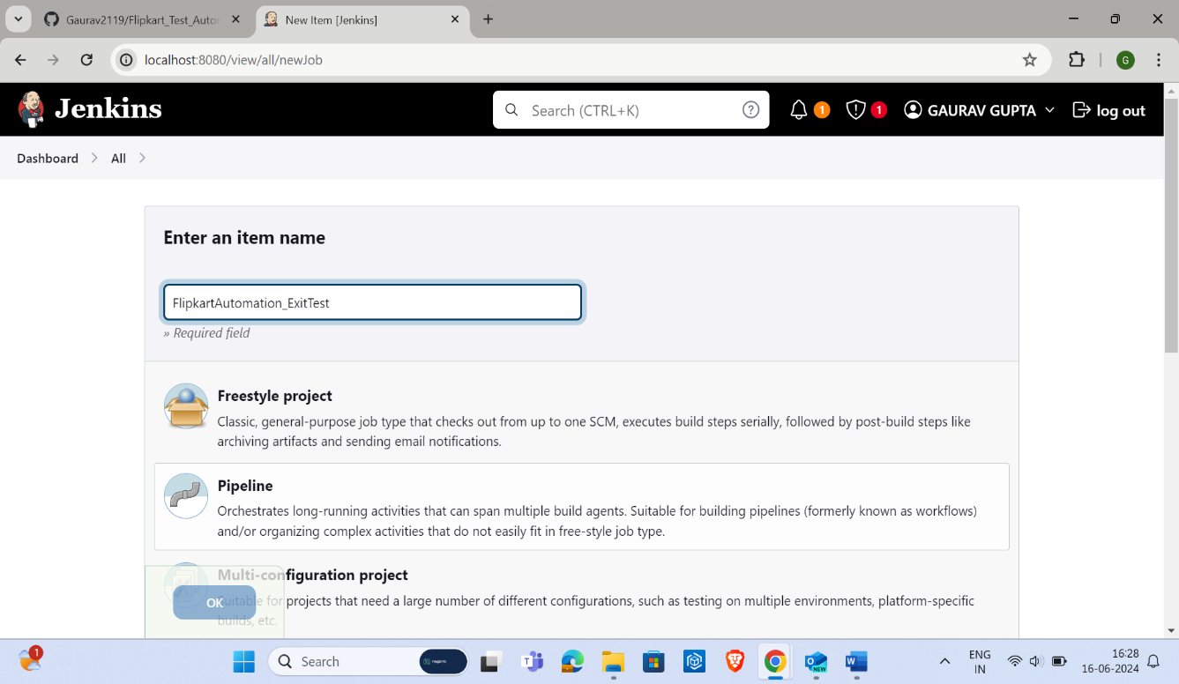

* 1. Configuring SCM with Git:

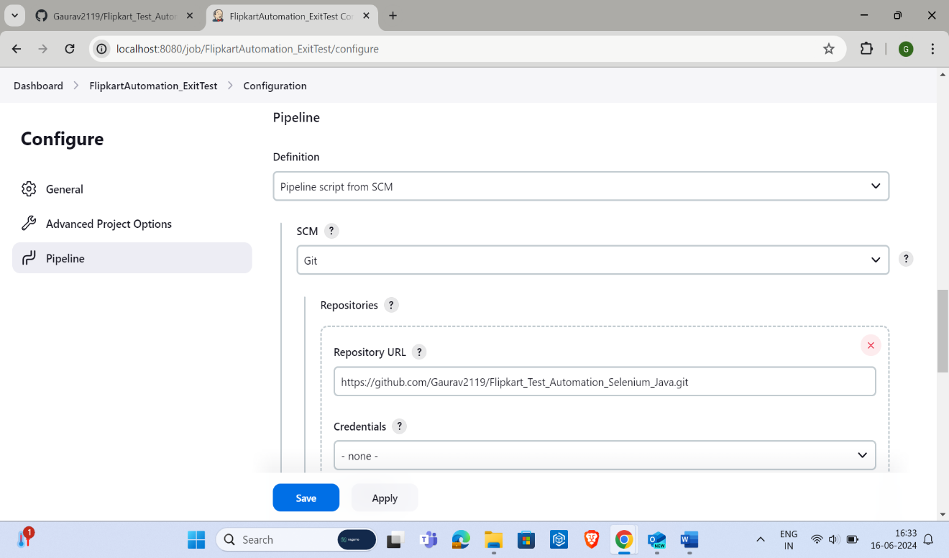

* 1. Setting Build Triggers:

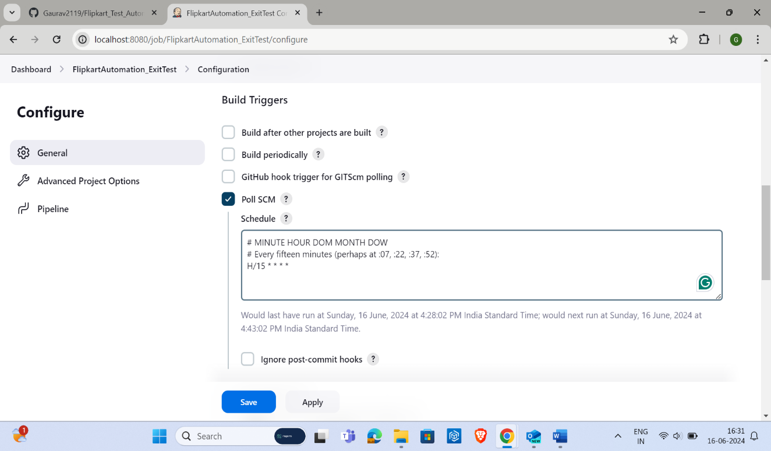

* 1. Configuring Build Steps:

Refer to JenkinsFile

1. Building the Job
   1. Triggering the build:
   2. Console output of the build:
2. Final Status
   1. Job status showing a successful build: